2024 Season Report

Like the previous two seasons- gumboots and wet weather gear was the clothing of choice during the first half of pruning. Then something weird happened! The rain eased for the second half of winter and the temperature dropped in its absence allowing the vine roots to breathe and the sap flow to slow right down.
This resulted in budburst pushing deeper into August than previous years and once it started, it raced through all varieties with the Cabernet Sauvignon only two to three weeks behind the Chardonnay.

Some heavy spring rain coincided perfectly with the arrival of our new tractor designed to give maximum traction on our sodden hillside slopes. This proved to be a game changer throughout the season by putting our new sprayer in the right place at the right time to avoid disease and provide timely nutrition.
After October the presence of a El Nino weather pattern began to be felt with aerated soils underfoot, moderate to low rainfall and long fine spells. During this time the vines thrived, and we were hard pressed keeping shoot growth between the training wires.

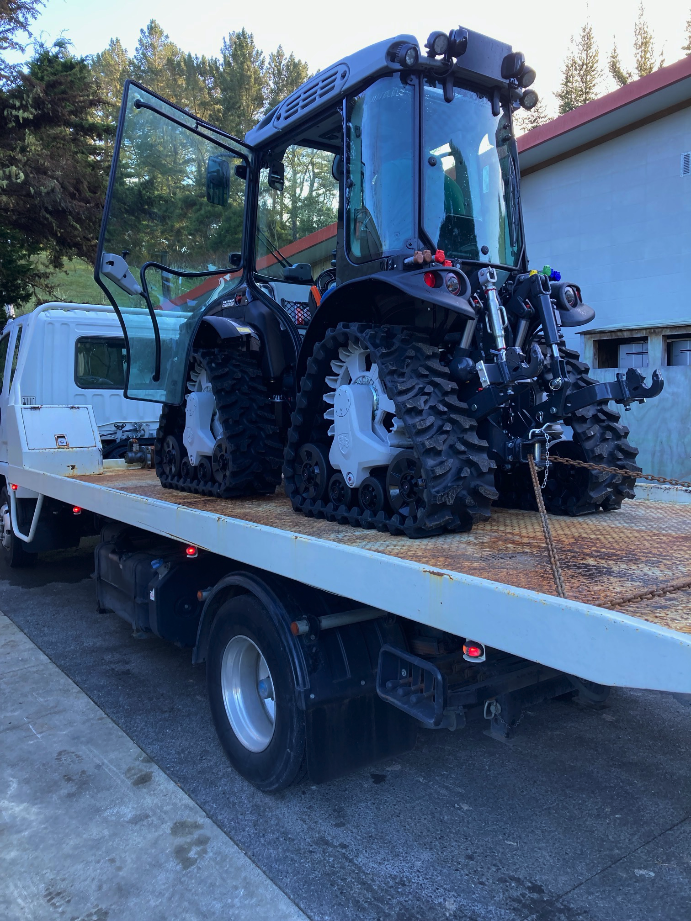 | 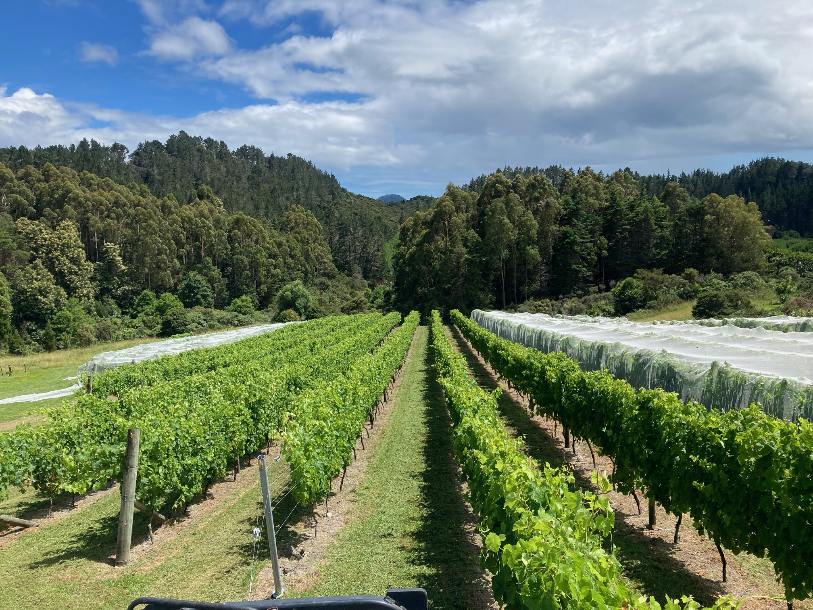  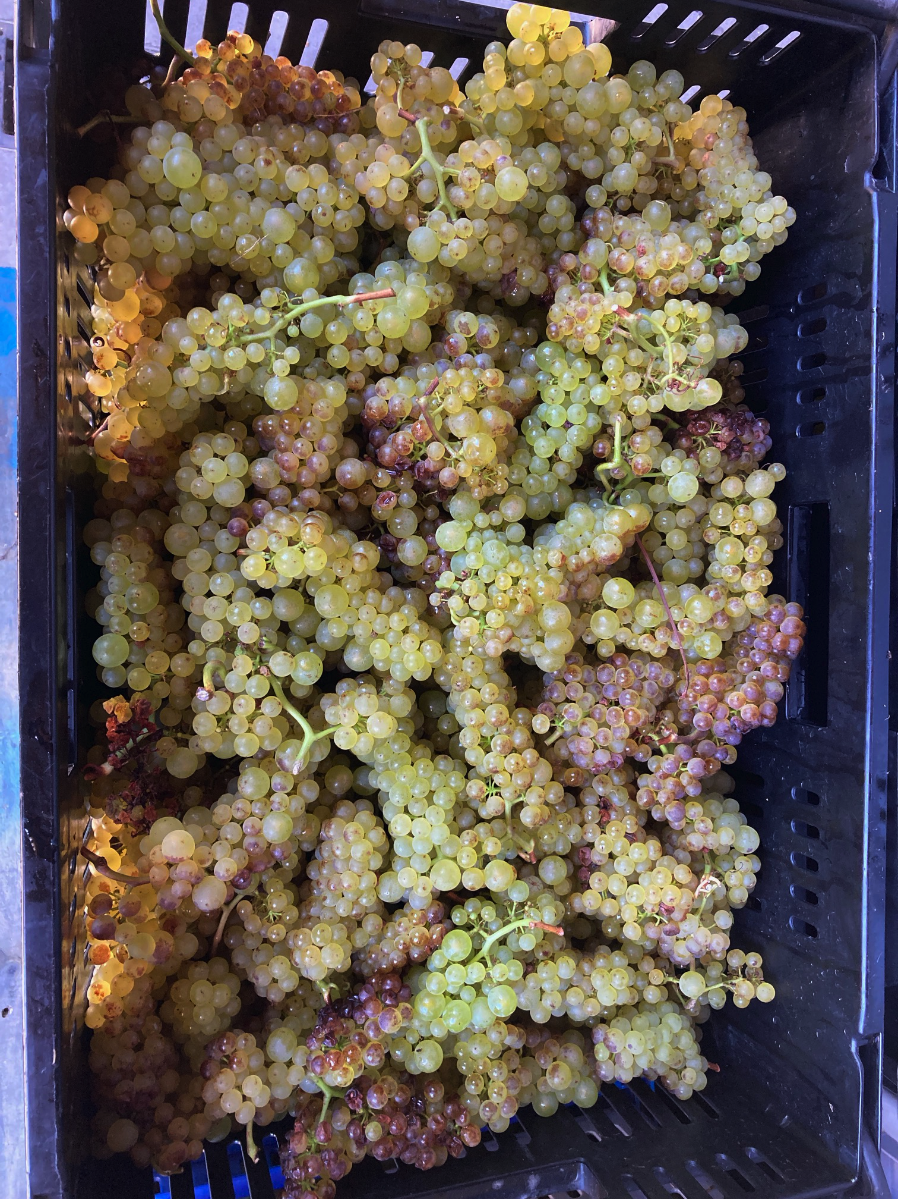

Come Christmas time the great weather had put us in a fantastic position and then something even weirder happened, the weather got even better! Long dry summer days prevailed and although the season started later than usual harvest began only a week behind usual- on the 15th of February.

Here are a few of the highlights of the vintage as they are too numerous to fit in one page.
- Immaculate Chardonnay including our somewhat problematic 1066 clone (see picture above highlighting its “hen and chick” berry sizing).
- Our first Pinot Gris harvest ever and the fruit was stunning and the wine instantly drinkable.
- Inky Syrah and Merlot that is loaded with spice and fruit just waiting to be paired with seasoned oak.

The 2024 harvest was the fruition of four seasons of hard graft leading up to it and has provided a clear benchmark for future seasons to come.

