2023 Season Report

We like to think that we are accustomed to rain and humidity up here in the winterless north, but 2023 was a revelation. Our annual rainfall (June to June) was over double the long-term average at a whopping 2300mm! The humidity spent most of the growing period over 80%, and we had weeks of nighttime lows of 20 degrees or more. This also culminated into a “hold onto your horse and strap yourselves for a wild ride” season.

Budburst was early due to a mild wet winter. As winter slid into spring- shoot, grass and weed growth became relentless and all we could do was try and keep up with it when conditions allowed. Flowering was affected by the rain and led to some poor fruit set particularly in the Chardonnay and Merlot. By Christmas we had knee high grass and sprawling canopies but for the most part the fruit was very clean.

Mowing, trimming and netting was done at frantic pace before the weather doubled down and sent cyclone Hale then cyclone Gabriele our way. Coming away from these two storms without damage to the vines and infrastructure was a relief and our hearts went out to those not so lucky.

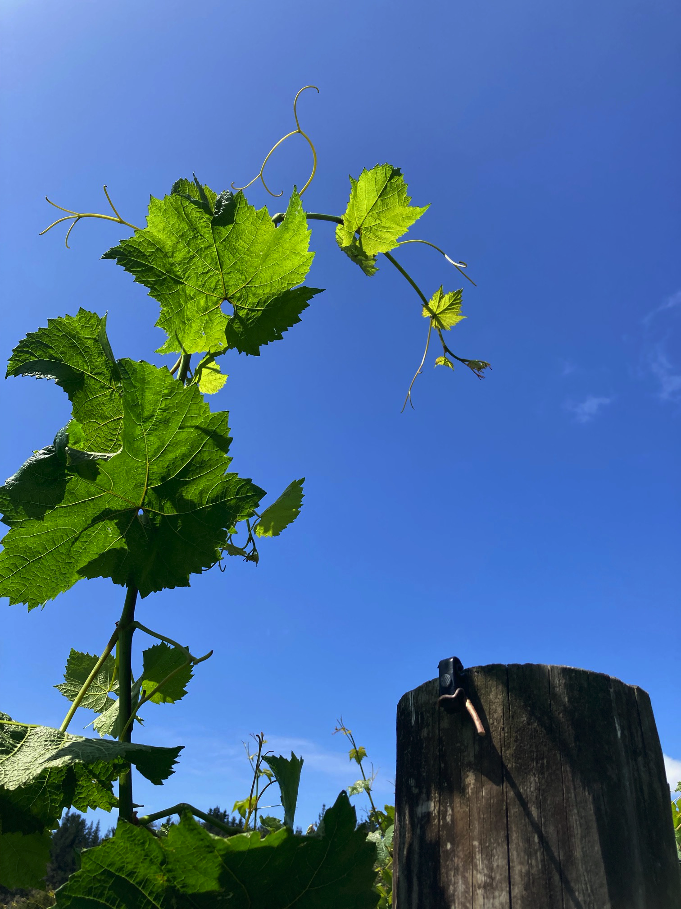 | 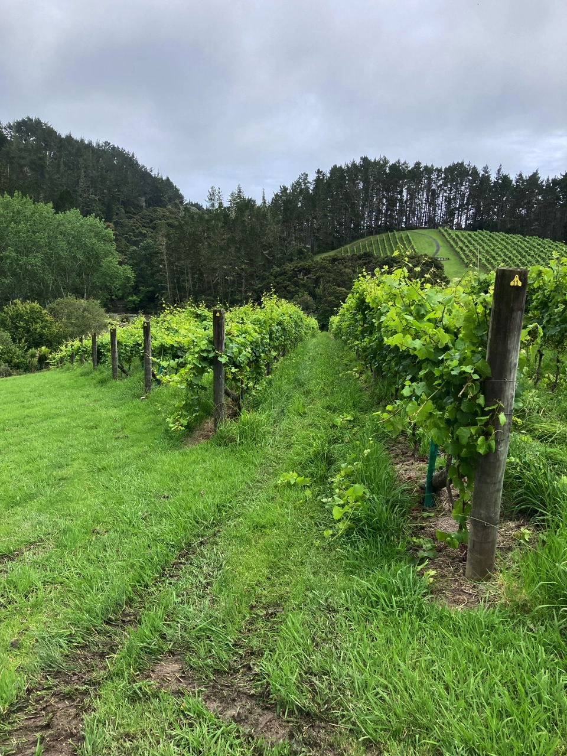  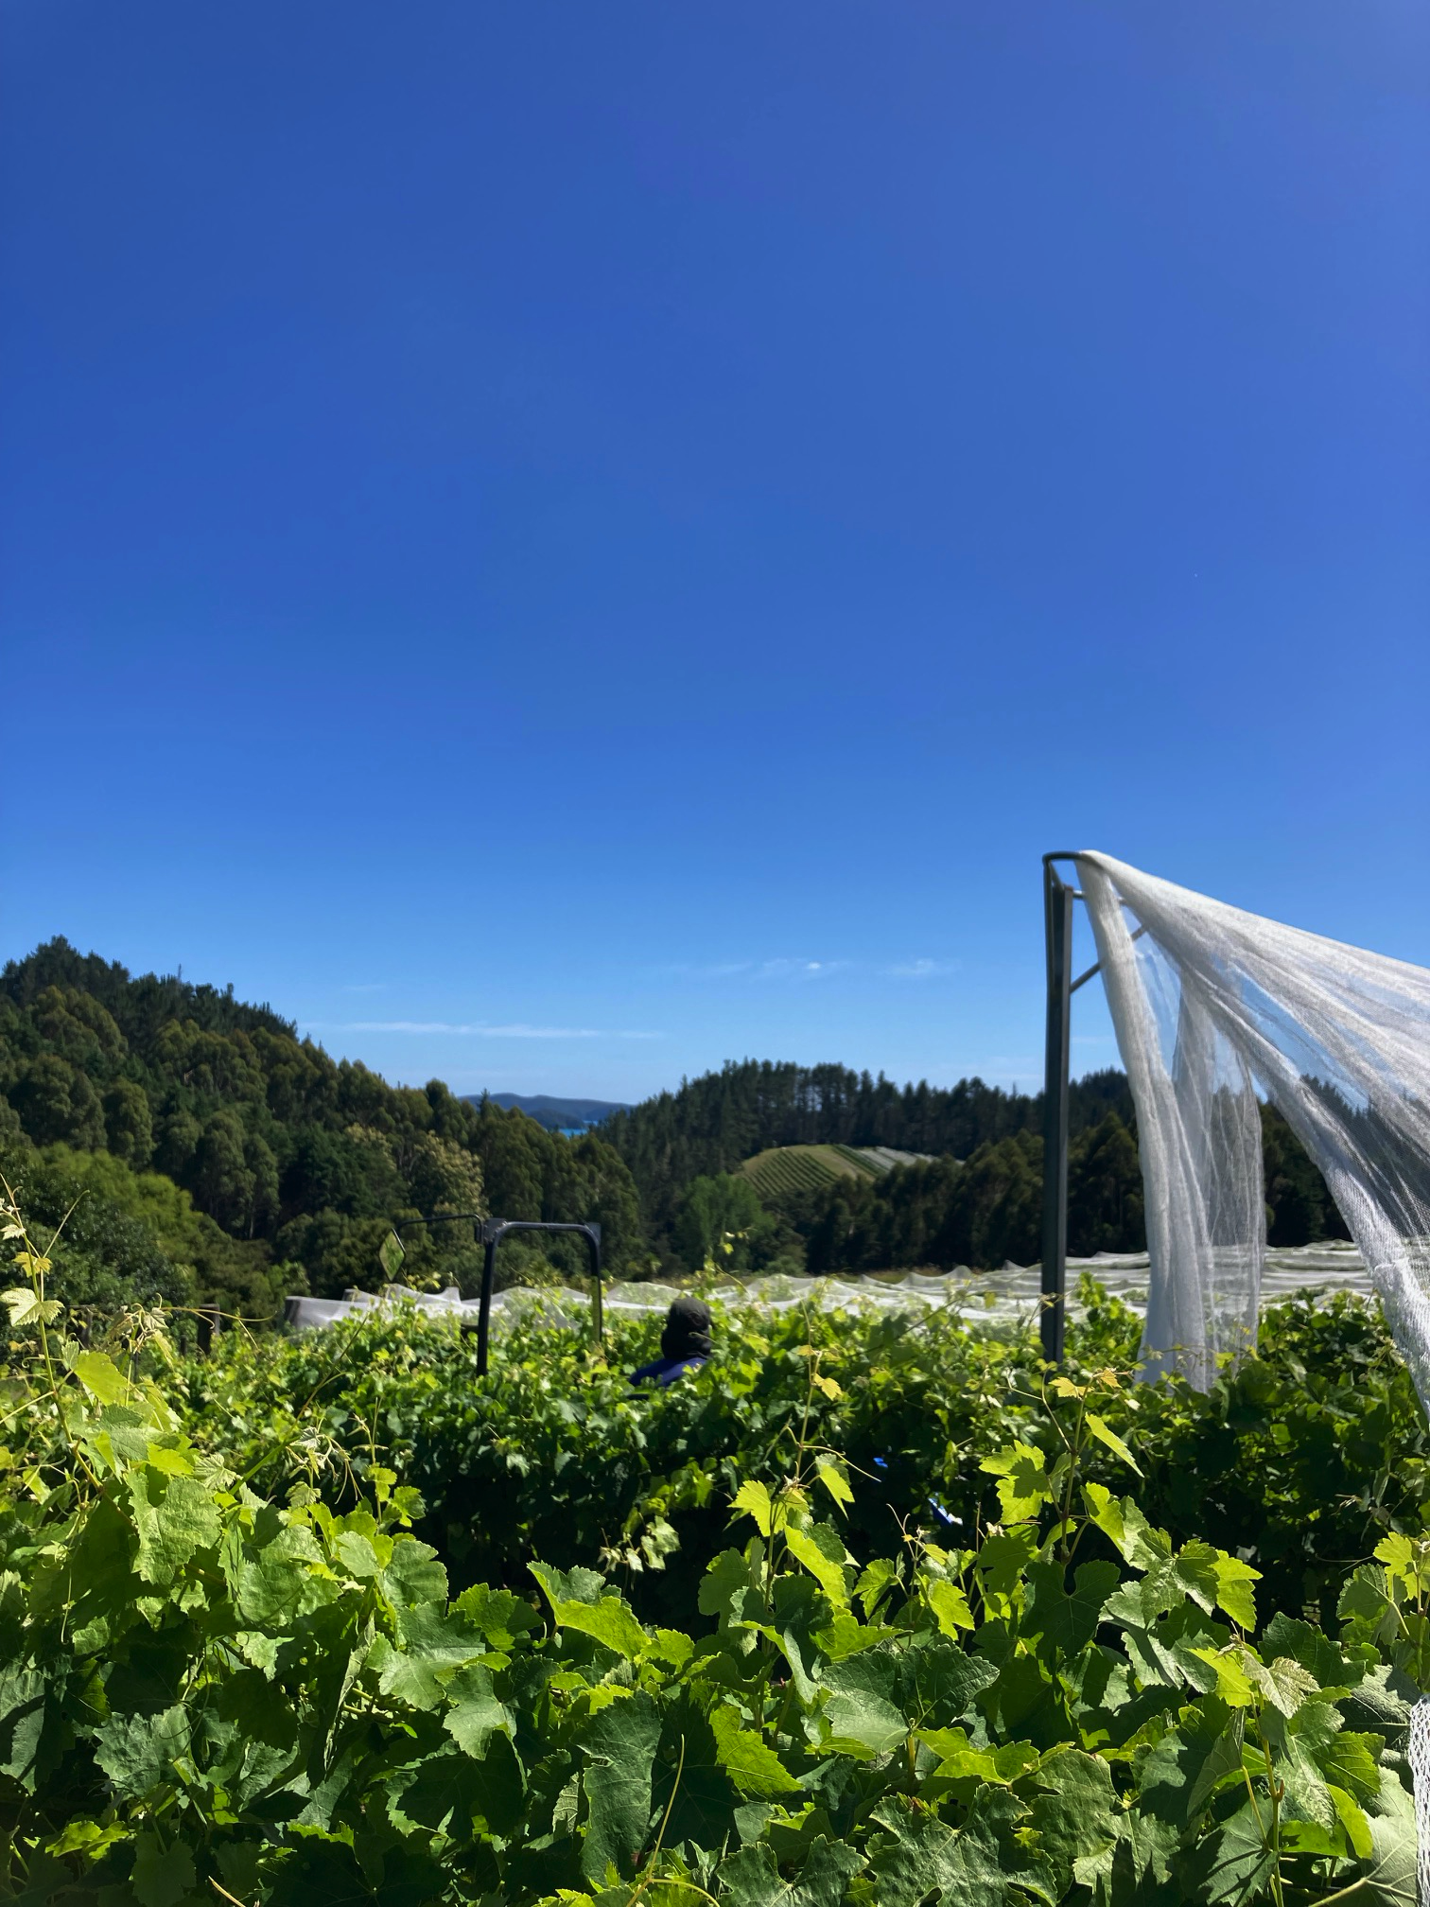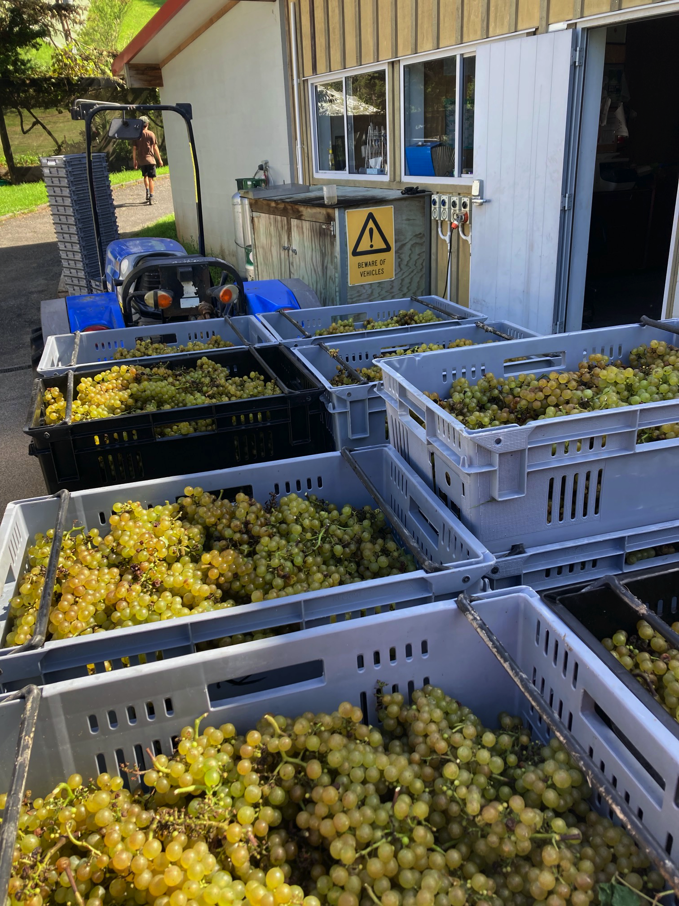
Picking began on the 9th of February with the Chardonnay, this was a slow process to ensure that only the best grapes made it into the bins. Then came the Rose and Sauvignon picks which again were a timely process. After the months that had proceeded it, March dished up a full reprieve from the monsoon with only 40mm of rain recorded. This allowed for us to hang the reds out until the end of the month and pick fruit that was expressive and vibrant.

The 2023 season was truly odd and the wines to come from it are putting it bluntly odd, low in alcohol and colour, packed with vibrant fruit flavours and soft acidity. These wines do not have the traits of what we typically strive for with our wines. However, the intensity, delicacy and overall balance they exhibit is truly unique and cannot be more intrinsically linked to the wild season in which they grew from. We are proud of these wines and the story they tell.

